**Q1.** Example-4: Given that,

B1: 3 Golds



B2: 2 Golds, 1 Silver

B3: 1 Golds, 2 Silver

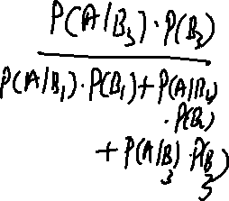

A person chosen a box at random and takes out a coin. If the coin is Gold. What is the probability that it was drawn from box 3?



**Solution:**



**Q2.** The % of adults who are men and alcoholics is 2.25 %. What is the probability of being an alcoholics, given being man?

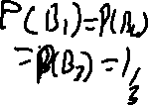

**Solution:**

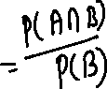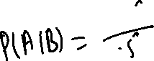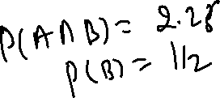

Q3





**Solution:**



Q4. Join Probability distribution:

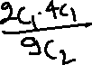

Two balls are selected at random from a box containing. 3-red, 2-green, 4-white. If X and Y are the number of red balls and green balls respectively, included among the two balls drawn from the box, find Join probability of X and Y.

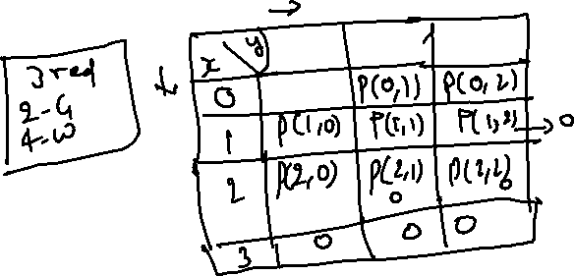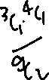

Q5. The Probability that a pen manufactured by a company will be defective is 1/10. If 12 such pen are manufactured. Find the probability that:

1. Exactly 2 will be defective

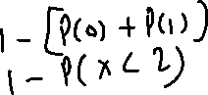

1. None will be defective
2. At least 2 will be defective

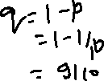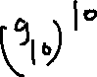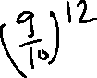

**Q6.** Let x be the number of births in a family until the 2nd daughter is born. If the probability of the having a male child is ½ . Find the probability that the 6th child in the family is the second daughter.

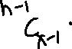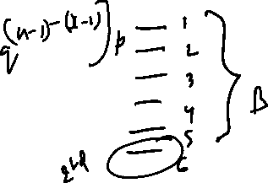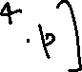

Q7. Given that 2% at the fuses manufactured by a firm are defective. Find probability that a box containing 200 fuses has



1. At least 1 defective fuses



1. 3 or more defective fuses



1. No defective fuses

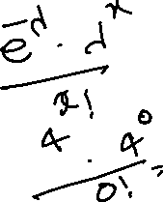

Q8. Suppose Ishan owns a pen manufacturing company and determines that 3 out of every 75 pens are defective. What is the probability that Ishan will find the first faulty pen on the 6th one that he tested?

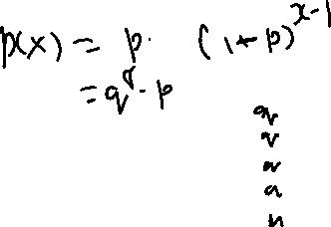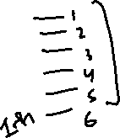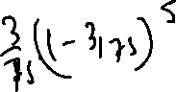

Q9. Bus is uniformly late between 2 and 10 minutes. How long can you expect to wait? With S.D ?

If its >7 mins late, you will be late for work.

What is the probability of you being late?

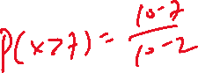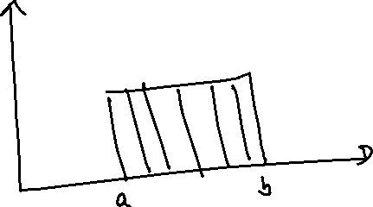

Q10. The distribution of 500 workers in a factory is approximately Normal with mean and SD Rs 75 and Rs 15, respectively.



* More than 90



* Less than 45



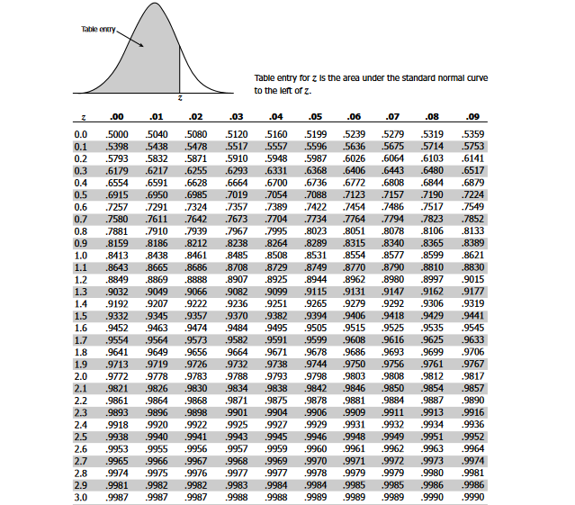



Q11. Let X = amount of time (in minutes) a postal clerk spends with his or her customer. The time is known to have an exponential distribution with the average amount of time equal to four minutes. Find the probability that a clerk spends four to five minutes with a randomly selected customer.

Sol.

We need to find P(4 < x < 5).

λ = 1/μ = ¼ = 0.25

We can plug in λ = .25 and x = 4 to 5

P(4 < x < 5) = P(x < 5) – P(x < 4)

P(X ≤ x) = 1 – e-λx

P(X ≤ 5) = 1 – e-.25(5)

P(X ≤ 5) = 0.7135

Similarly, P(X ≤ 4) = 0.0814

Hence, P(4 < x < 5) = P(x < 5) – P(x < 4) = 0.7135 − 0.6321 = 0.0814.